launching of classic Laundromat in orlando city,  on December 17th, 2019 | - classic laundromat  - we are the;  - champions of cleanness!!!!
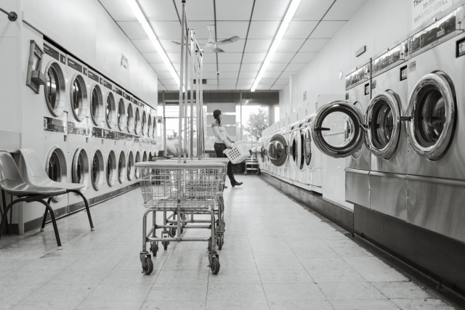  Classic Laundromat  NOW OPEN!!! WELCOME ALL  CLASSIC LAUNDRY OFFERS:  - Laundry services for commercial, hotel, hospitality, industries etc.  - Top quality cleaning of clothes services to Hospitals, Restaurants, Hotels and Serviced Apartments.  - Welcome we guarantee for the softness of the Towel, the Whiteness of a napkin, and the Crispness of a sheet.  - We all create best judgment based on the small things. | 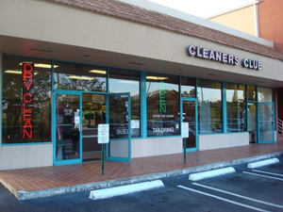  ABOUT US!!  225W. State Street  Orlando City, Florida 08608  Tel: (609) 292-2470  Web: www.classiclaundry.com  Email: classiclaundry@gmail.com  CCLEANNESS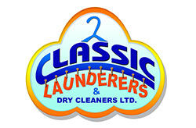  CLEANNESS IS NEXT TO GODLNESS

